  Decommission of Campaign Tagging & Tracking tool  3.0 | High Level summary  Document the integrated actions to ensure a successful decommission of the CTT Tool  Author Name  Amanda Pattenden

Revision History
Date | Version | Description | Author
25/11/2025 | 1 | Initial draft | Amanda Pattenden
03/12/2025 | 2 | Comment Updates | Amanda Pattenden
08/12/2025 | 3 | Addition or Enhaced Requirements to include dual Task ID Capture | Amanda Pattenden

Table of Contents

1. Introduction 4
Problem Statement – Why? 4
Vision – What? 4
Benefit Summary – Who? 4
2. Scope and Limitations 4
In-Scope 4
Out of Scope 4
Assumptions 5
Dependencies 5
Success Metrics 5
3. Business Process 6
Business Process – As Is (Current State) 6
Business Process – To Be (Future State) 6
4. Stakeholder Requirements 7
Stakeholders 7
Integrated Tools 7
Allocadia 7
Eloqua 7
Salesforce 8
Tray.io 8
VDC Engage/Manual Upload Request 8
Marketing Automation 8
App Cloud Lite 9
Stensul 9
Demand Intake Tool 9
MRF 10
Tray.io 10
Lean Data 10
Gong Engage 10
CDF 10
Workfront 10
Web Integration 11
Reporting 11
Enriched Requirements 12
5. Summary of Impacts 13
6. Glossary of Terms 14
Glossary 14
7. Approvals and Sign-Off 15
Document Reviewers 15

- Introduction

Problem Statement – Why?
The core problem is that the existing Campaign Tagging and Tracking (CTT) Tool relies on inconsistent and outdated legacy identifiers (CCID, OID, DTID) collectively known as Omni Channel IDs (OCID), resulting in inaccurate reporting, poor data governance, and an overly complex data architecture that relies on intermediary systems

Vision – What?
The primary driver for decommissioning the CTT is to modernize our marketing technology stack and standardize tracking methodology. This involves replacing legacy, inconsistent identifiers (OCID’s) with the Task ID and standard web tracking parameters (UTM values). This shift will lead to more accurate reporting, improved data governance, and a simplified data architecture, eliminating reliance on intermediary systems like the CDF Transaction Tables.

Benefit Summary – Who?
Decommissioning of the CTT Tool benefits anyone relying on marketing data for reporting, analysis, or strategic decision-making, as well as the engineers and administrators responsible for maintaining the system's infrastructure and compliance.
- Data Quality and Governance: The shift from inconsistent legacy identifiers (OCID’s) to the standardized Task ID and UTM values leads to more accurate reporting and improved data governance.
- Technology and Architecture Teams: They benefit from a simplified data architecture, as the initiative eliminates reliance on complex, intermediary systems like the CDF Transaction Tables.
- Marketing and Analytics Teams (System Users): These teams benefit from accurate tracking and standardized data capture, which will lead to better insights from web analytics, lead scoring, and campaign performance measurement.

- Scope and Limitations

In-Scope
The scope of this initiative is the complete decommissioning and removal of the legacy Campaign Tagging and Tracking (CTT) Tool and all of its corresponding integrations. This includes the mandated standardization of all sales and marketing data capture, reporting, and tool requirements that currently rely on legacy identifiers (OCIDs). All affected systems must be updated to exclusively capture and utilize the Task ID from Workfront and industry-standard UTM values for campaign tracking and attribution.

Out of Scope
- The scope mandates using the Task ID from Workfront, but any fundamental changes to how projects, tasks, or budgeting are managed within the Workfront system itself (beyond ensuring the Task ID is accessible) would be out of scope.
- The project is about replacing one set of IDs with an existing, defined set (Task ID and UTM values). Developing or implementing any entirely new or custom tracking fields, codes, or methodologies outside of this defined standard is out of scope.
- While the project involves updating integrations with systems like Eloqua and Allocadia, it does not involve upgrading, migrating, or replacing those core systems
- The project focuses on ensuring future data capture and current reporting are standard. The historical migration or transformation of old CTT-related data (CCIDs, OCIDs) stored in data warehouses (like Snowflake or old CDF backups) to align with the new Task ID is typically out of scope unless explicitly defined as a migration task.
- Addressing general data quality problems, such as inaccurate contact information or duplicate records, is out of scope unless the issue is a direct result of the legacy CTT identifiers.

Assumptions
- Task ID Readiness: The Task ID from Workfront is guaranteed to be a unique, stable, and consistently available identifier at the precise point of all system integrations required by this project.
- UTM Standardization: A clear, finalized, and documented governance standard for all UTM values has been approved by marketing leadership and will be distributed to all system owners before development begins.
- Task ID Coverage: Every sales and marketing initiative that previously required an OCID can be accurately assigned a Task ID from Workfront.
- Integration Inventory Completeness: The list of tools and integrations identified in the requirements (including Allocadia, Eloqua, CDF, and all third-party systems like Rainfocus, Webex, etc.) represents the complete and exhaustive set of systems relying on the CTT and its legacy identifiers. No critical, undocumented dependency exists.
- All Historical Data: The project is not responsible for the retrospective conversion or migration of historical data that contains legacy CTT IDs (CCID/DTID/OID) to the new Task ID standard (i.e., no retroactive updating of old lead history records). Historical data mapping will be handled separately
- Forward Audit: Due to the high volume of traffic originating from legacy systems (87% of digital leads generated in FY26 are from Eloqua), a mandatory audit and cleanup phase must be completed. This audit will identify and track down all live web pages, offers, and lead-generating assets that are still utilizing and generating traffic with legacy CTT identifiers. The identified sources must be updated to the new Task ID/UTM standard before the official CTT decommissioning date to prevent data loss.

Dependencies
- Resource Availability: Dedicated development and functional resources from all affected system owner teams (e.g., Eloqua team, Web team, Allocadia team) will be available and prioritized to execute the required integration changes within the project timeline.
- Source System Readiness for Reporting: The destination "source systems" identified for future reporting (replacing the CDF Transaction Tables) are stable, accessible, and contain all the required data fields necessary to meet current reporting requirements.
- Audit Success: The web audits and form audits on .com pages will successfully identify all instances of legacy IDs (CCID/DTID/EID/OID) to ensure 100% removal in accordance with the scope.
- Workfront Task ID Standard: Final approval and deployment of the Task ID as the official identifier must be completed before development begins on any integrating tools (e.g., Eloqua, Tray).

Success Metrics
- CTT Retirement: The legacy CTT application is fully decommissioned and shut down by the target end date.
- Zero Legacy ID Exposure: Zero occurrences of legacy identifiers (CCID, OID, DTID, etc.) found in production web pages, forms, or hidden fields post-migration.
- 100% Task ID Adoption: All new campaign activations and data intake forms successfully capture and utilize the new Task ID and required UTM values.
- Reporting Continuity: All critical reports dependent on legacy CTT data sources maintain validated accuracy upon migration to the new source systems.

- Business Process

Business Process – As Is (Current State)
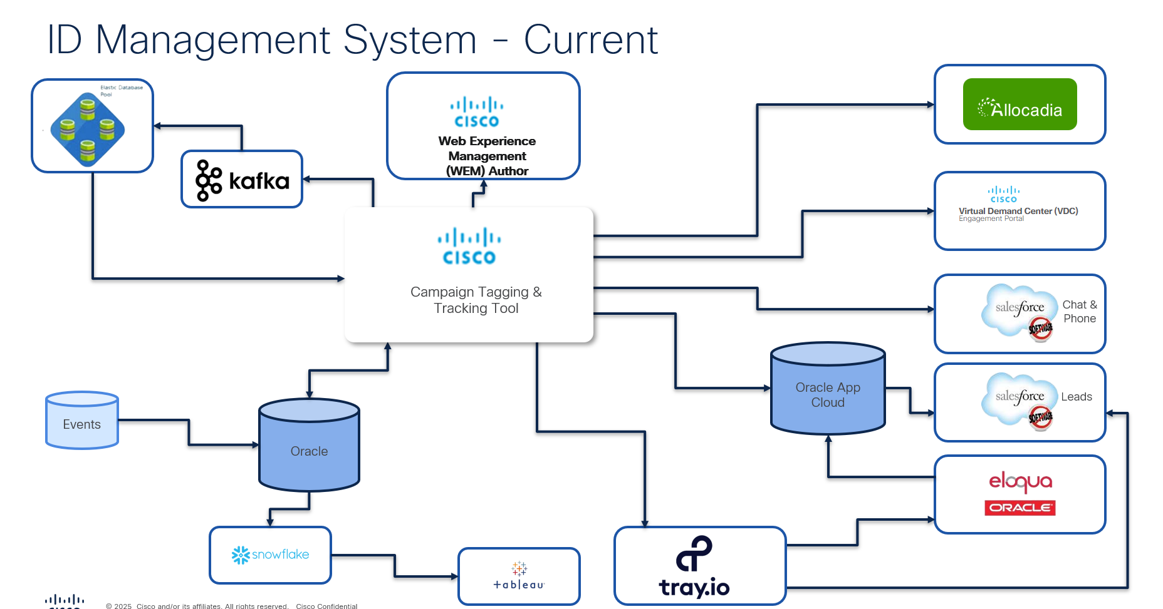

Business Process – To Be (Future State)
<Is the future state of an as-is process in the format of a business process flow>

The future state will be determined by Data and Tools Teams after determining requirements
This is a conseptual business flow only – it is in NO WAY a data flow diagram
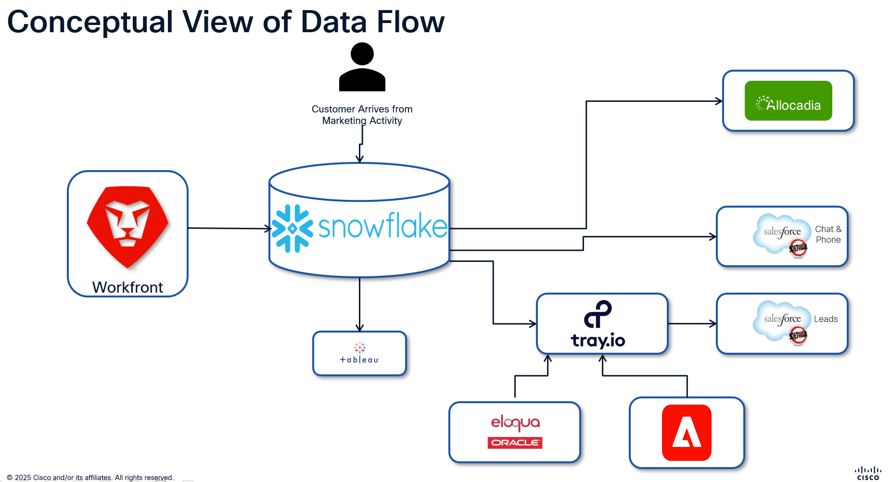

- Stakeholder Requirements

Stakeholders
Stakeholder | Code | Description
Integrated Tools | IT | Existing integrations with the CTT Tool that need to be decommissioned
Marketing Automation | MA | Use of IDS within our marketing and sales integration tools
Web Integration | WI | Data capture for customer touchpoints via their digital journey
Reporting | RE | Data references to OCID’s
Enriched Requirements | ER | While these requirements are not mandatory for decommissioning, adding them now—while systems are in scope—is necessary to capture the full data needed for both driving and consumed marketing initiatives

Integrated Tools

Allocadia

IT001: As a Finance User, I want to link marketing campaigns and programs to budget information, but remove the integration between the CTT Tool and Alocadia, so that I can accurately align campaign spending with the defined budget

Eloqua

IT002: As a Marketing Automation Specialist, I want to decommission the integration that creates picklists in Eloqua from the CTT Tool, so that I can utilize modern, external data sources to feed and manage my Always-On Journeys (AOJs).

Salesforce

IT003: As a Data Engineer, I want to remove the CTT validation dependency when creating a new lead in SFDC and instead populate marketing information from a more efficient source (e.g., Task ID/UTM source systems), so that lead creation is faster and relies on the new, accurate data structure.

IT004: As a Data Engineer, I want to remove the CCID alignment from the inbound call process that generates a lead and campaign alignment, so that we eliminate all legacy ID usage in the call-to-lead flow.

IT005: As a Data Analyst, I want to align inbound chat sessions to the UTM_ID if initiated by a marketing effort and to a generic source if direct/organic, so that we accurately track and attribute marketing-driven chats while maintaining visibility on non-campaign chats.

Tray.io

IT006: As a Data Engineer, I want to remove the Tray process that extracts OCID-aligned data attributes and instead utilize the Task ID for passing data downstream to SFDC, so that we standardize the data exchange using the new tracking methodology.

IT007: As a Data Engineer, I want to remove the automatic creation of SFDC Campaigns at CCID and OID levels that rely on the CTT Tool, so that we eliminate the reliance on legacy identifiers and simplify SFDC campaign creation.

IT008: As a Data Engineer, I want to remove the process that adds leads to SFDC campaigns based on CCIDs and instead utilize the Task ID for lead alignment, so that lead attribution is accurate and aligned with the new campaign tracking standard.

VDC Engage/Manual Upload Request

IT009: As a System Administrator, I want to decommission the CTT integration with the VDC Engagement Portal and review the VDC tool's requirement after Workfront intake is live, so that we simplify the architecture and ensure all tools are essential.

Marketing Automation

Eloqua

MA001: As a Marketing Manager, I want to amend Eloqua URLs to utilize UTM values instead of CCID and DTID, so that all outbound links reflect the new standardized tracking methodology.

MA002: As a System Administrator, I want to audit high-use forms to determine which submissions require updating, then amend their hidden fields by removing OID and CCID and replacing them with a Task ID, so that I can prioritize data compliance and accurately link the most critical form submissions to specific tasks for tracking and reporting.

MA003: As a Marketing System Administrator, I want the tools integrating directly into Eloqua via form submit (Integrate, Webex, LinkedIn, Pathfactory, BrightTalk, and Brightcove) to remove the link to OCIDs and change to capture Task ID, utm_source, and utm_medium, so that I can eliminate reliance on legacy identifiers and improve campaign tracking and attribution within Eloqua.

MA004: As a Marketing Manager, I want form submissions to capture and pass UTM values (ID, Source and Medium) downstream to App Cloud Lite, Tray, and SFDC, so that we ensure a consistent and modern tracking standard across all lead processing systems.

MA005: As a Data Analyst, I want to amend Automated Operations Jobs (AOJs) to utilize UTM_ID values instead of Activity ID, and break down data by elements related to the Workfront Task (such as campaign, program, and stakeholder group), so that I can generate highly granular and relevant reporting based on the new structure.

App Cloud Lite

MA006: As a Data Engineer I want to amend Lead Scoring programs and update the corresponding validations within App Cloud Lite to capture the last UTM values instead of legacy CTT Values, so that lead scoring logic is based on current and actionable touchpoint data.

MA007: As a Data Engineer, I want to amend App Cloud Lite's lead scoring logic to prioritize event transactions using only the Event ID (EID), and ensure the Oracle lead scoring validation is updated to prevent record suppression due to the absence of the retired CCID, so that event-based leads are scored accurately and without interruption

Stensul

MA008: As an Marketing Manager, I want to amend Stensul URLs to drive UTM values instead of CCID, DTID, and OID, so that all email tracking is standardized and aligned with the new governance.

Demand Intake Tool

MA009: As a System User, I want to remove the alignment of my manual uploads to an Activity ID, but be able to obtain more comprehensive information from the Task ID, so that I can accurately pass informaiton downstream to relevant marketing automation tools for standardized campaign tracking

MA010: As a System Administrator, I want to amend the validations for event uploads in the Demand Intake Tool to reference the Event ID (EID) instead of the CCID, so that event data is accepted based on the new standardized identifier.

MA011: As a Data Engineer, I want the Event lead enrichment process to rely exclusively on Events data, rather than Workfront or CTT data, so that all event-originated leads receive accurate and independent data enrichment.

MA012: As a System User, I want to remove any referece of DTID and OID from the manual upload template and any associated upload validations on those fields so that we can eliminate the use of legacy identifiers and streamline the data upload process.

MA013: As a System User, I want to capture utm_medium and utm_source on manual uploads,so that this attribution data can be passed downstream to the relevant marketing automation tool for improved channel analysis.

MRF

MA014: As a Marketing Administrator, I want to amend the Marketing Request Form (MRF) to directly capture all necessary data elements for reporting, eliminating its reliance on lookups from both CTT and Workfront data sources, so that the MRF serves as a self-contained, accurate, and independent data source for immediate reporting.

MA015: As a Data Engineer, I want to amend the data integration from Event tools (Rainfocus, Cvent, Stova, Jaguar) to our Marketing Automation systems to replace reliance on CCID with the Event ID (EID), so that all integrated event data uses the primary, standardized identifier.

Tray.io

MA016: As a Data Engineer, I want to remove all intake validations within Tray that reference OCIDs, and replace them with Workfront data-based validations for future implementation, so that the integration workflow eliminates dependency on legacy identifiers and aligns with the new data standard

MA017: As a Data Engineer, I want the Tray workflow for processing hand-raiser event leads to rely solely on the Event ID (EID) and utilize the Events data source for all lead enrichment, completely bypassing Workfront or CTT data, so that event leads are processed accurately and efficiently using the standardized, primary event identifier and independent data source.

Lean Data

MA018: As a Sales Operations Analyst, I want to remove all lead routing logic dependent on OCID and replace it with the new Task ID or UTM-based fields, so that lead assignment remains accurate and does not fail when the legacy CTT identifier is retired.

Gong Engage

MA019: As a Sales Operations Analyst, I want to updated nurturing sequences in the VDC to rely on Task ID attributes instead of CCID or OID, so that VDC sellers' multi-touch engagement sequences are triggered by the correct, current campaign identifier.

CDF

MA020: As a System Administrator, I want the data pulls by CDF from Eloqua based on OCIDs to be stopped, so that I can decommission the old data integration pipeline and ensure data compliance by ceasing the transfer of legacy identifiers.

Workfront

MA021: As a System Administrator, I want to amend the automated and manual UTM Builder tools to support the standardized UTM values and eliminate the inclusion of legacy identifiers (CCID and DTID) in URL parameters, so that we enforce the new tracking methodology across all campaign creation tools.

Web Integration
WI001: As a Web Developer, I want to capture UTM parameters instead of CCID, DTID, and OID on driving traffic, so that website analytics accurately reflect the source of inbound traffic using the new standard.
WI002: As a System Administrator, I want to audit the highest-traffic page touchpoints to update them to capture the Task ID, so that I can accurately track user journeys and attribute actions to specific tasks for better analytics and performance monitoring.
WI003: As a System Administrator, I want to audit all .com pages to remove every URL reference to CCID, DTID, EID, and OID, so that I can enhance user privacy, improve security, and standardize URL structure across the site.

WI004: As a Web Developer, I want to remove all website page logic that references OCIDs and utilize the Task ID instead, so that the website codebase is free of legacy identifiers and aligned with the new tracking standard.

Reporting

RE001: As a Data Analyst, I want all reporting queries and dashboards to stop referencing the CTT Tool and utilize the Workfront Data within snowflake, so that we eliminate reliance on deprecated sources and ensure reports use only governed, live data.

RE002: As a Data Analyst, I want a mapping logic/table established between all legacy identifiers (CCID, DTID, OID) and the new Task ID, so that historical performance data can be aggregated and reported alongside current campaigns.

RE003: As a Data Analyst, I want all reporting queries and dashboards to stop referencing the CDF for channel information and utilize the source data for each channel within snowflake, so that we eliminate reliance on deprecated sources and ensure reports use only governed, live data.

RE004: As a Reporting User, I want all historical and active reports to remove filtering based on CCID, DTID, or OID, so that report filters only use the new Task ID attributes and UTM-based fields for accurate segmentation.

RE005: As a Report Developer, I want to create new calculated fields based on the UTM parameters (e.g., UTM_Source, UTM_Medium) and Workfront Task ID, so that I can build comprehensive, future-proof reports aligned with the new tracking governance.

RE006: As a Report Developer, I want to retire all reports that rely solely on legacy CTT data, so that end-users are guided exclusively toward reports based on the new, standardized UTM and Task ID structure.

RE007: As a Data Engineer, I want to remove data references to the CDF Transaction Tables based on OCIDs and Transaction Types and move the reporting to the source system of the transaction, so that I can decommission the legacy CDF tables, simplify the reporting architecture, and ensure we are using the most accurate, real-time transaction data.

Enriched Requirements

The core CTT Decommissioning project ensures we eliminate legacy OCIDs and meet the standards of 0 Legacy ID Exposure and 100% Task ID Adoption.
However, the addition of the new requirements (capturing both the Marketing Task ID and the Page Task ID) is a strategic scope expansion that will:

- Unlock Full Unified Marketing Intelligence: This work moves us beyond simply retiring a legacy ID and delivers the ability to seamlessly stitch the customer journey—from the driving marketing initiative (utm_id) to the specific offer consumed (Page Task ID).

- Ensure Complete Attribution: By capturing both identifiers across the web, forms, App Cloud Lite, and Tray, we guarantee that reporting analysts can accurately attribute value without double-counting.

- Optimize Resource Efficiency: The CTT decommissioning project provides a one-time, cost-effective window to touch and amend the hidden fields and validation logic in all foundational systems (Web, Eloqua, Tray, SFDC). Implementing this enhanced tracking now prevents a costly, complex follow-up project that would be required to achieve the same enriched data capture later.

While not mandatory for CTT tool removal, these requirements are critical for delivering the full value of the Unified Marketing Intelligence Project and must be prioritized now while the relevant systems are already in scope.

ER001: As a Web Developer, I want to capture the UTM_ID (Marketing Project Task ID) and the Page Task ID when a customer arrives on .com so that I can utilize both IDs for detailed Web reporting and link customer behaviour back to the driving marketing initiative

ER002: As a Marketing Manager, I want the system to capture the UTM_ID (Marketing Project Task ID) and the Page Task ID in Eloqua upon submission so that the marketing initiative and page context are recorded with my lead data for downstream processing

ER003: As a Marketing System Administrator, I want to pull the UTM_ID (Marketing Project Task ID) if available for handraiser leads from the Transaction CDO so that I can pass it to Tray for subsequent marketing data enrichment

ER004: As a Marketing System Administrator, I want to pull the UTM_ID (Marketing Project Task ID) if available for scored leads from six standard CDO's so that I can pass it to Tray for subsequent marketing data enrichment.

ER005: As a Data Engineer, I want to enrich the lead with data attributes from both the UTM_ID (Marketing Project Task ID) and the Page Task ID so that the complete, enriched lead can be passed downstream to other systems.

ER006: As a Sales User (Seller), I want SFDC to record and clearly display the relevant data attributes from both the UTM_ID and the Page Task ID so that I can quickly understand the lead's driving marketing initiative and page context.

ER007: As a Reporting Analyst, I want the data to clearly differentiate between the UTM_ID (Marketing Project Initiative) and the Page Task ID (Offer Consumption) so that I can accurately attribute value without double-counting in marketing performance reports.
As a Data Engineer, I want to capture both the Page Task ID and the UTM_ID (Marketing Project Task ID) when a chat is initiated and a lead is generated in SFDC so that reporting teams can reference and link the lead back to specific marketing data attributes.

5. Summary of Impacts

Tool | Summary | CTT Direct Integration or Aligning Process
Allocadia | Remove direct integration with CTT and replace with Workfront Data in the future | Integration
DIT/Tray | Removal of validations of IDs on upload | Process
Tray | Remove direct integration with CTT for ID attributes appended to the lead and replace with Workfront Data | Integration
DIT/Tray | Utilize UTM values instead of DTID | Process
CDF | Remove transaction data pull based on IDs | Process
Tray | Remove direct integration to create SFDC Campaigns by CCID and OID | Integration
MRF | Remove mandatory OCID values and align MRF to Capture the necessary data Attributes needed for reporting and lead enrichment | Process
Events > Eloqua | Remove mandatory OCID fields and replace with MRF EID | Process
Tray | Stop the addition of SFDC Campaign members by CCID for new leads generated | Process
SFDC | Remove the validation of CTT infromation for new leads generated by Call, Chat and Marketing | Integration
SFDC | Add UTM and Workfront Data to SFDC Leads | Process
Lean Data | Remove any routing instructions based on OCIDs | Process
Off Line Activities > Eloqua | Remove mandatory OCID fields from integrations into Eloqua such as Integrate, BrightTalk, Pathfactory and replace with Workfront and UTM values | Process
Eloqua > App Cloud Lite | Remove the restrictions on pulling lead data from Transaction CDO with OCID’s and replace with Task ID and UTMs from form Submit | Process
Eloqua > App Cloud Lite | Remove the restrictions on pulling scored data from 6 CDO with OCID’s and replace with Workfront Data and UTMs | Process
Eloqua > App Cloud Lite | Amend restrictions on lead scoring app cloud lite to validate EID when lead was generated from Events Integration | Process
Eloqua | Remove the creation of CTT Picklists and their alignment to AOJS | Integration
Eloqua | Audit of high touchpoint pages to have alignment to Task ID instead of OID | Process
Stensul | Remove mandatory OCID values from URLS and replace with UTMS and Workfront Data | Process
Ace Reports | Remove Reliance of OCID from CDF | Process
Ace Reports | Utilize UTMs for reporting against Leads and pages instead OCID | Process
Web | Page Data Capture of UTM’s and Workfront Data instead of OCIDS and page logic | Process
Ace Reports | Map OCID values to align to New Workfront values to ensure we are able to report on Year on Year data | Process
VDC Engage | Remove the integration between CTT and VDC Engage and determine the future of that product | Integration
UTM Builders | Amend Workfront and Manual UTM Builders to exclude OCID and standardize UTM | Process

6. Glossary of Terms

Glossary
<An alphabetical list of terms in a particular domain of knowledge with the definitions for those terms>

Acronym | Description
SLA | Service Level Agreement
KPI | Key Performance Indicators
UTM | Urchin Tracking Module
VDC | Virtual Demand Centre
SIIA | Strategy, Investments, Insights and Analytics
OCID | Omni Channel ID – collection of Campaign Tagging and Tracking IDs
CCID | Common Campaign ID – also referred to as Activity ID
OID | Offer ID
DTID | Drive To ID
SFDC | Salesforce .com
Task ID | The Workfront Task ID situated on each page – the Task ID captured will be the Task of the Consumed Offer
Project Task ID | The Workfront Task ID that will be included in the UTM_ID parameter that reflects the marketing initiative that is driving the customer to .com
CTT | Campaign Tagging and Tracking Tool

- Approvals and Sign-Off

Document Reviewers
Name | Reviewer | Approver | Date
Amanda Pattenden |  | X
Jessica Bauerlein Widener |  | X
Chris Shatara |  | X
Stephanie Boyd | X
Christy Parker | X
Jasper Peck | X
Chaitanya Nimmala | X
Nadia Southerland | X
Sanjay Gupta |  | X
Prakash Pethe | X

